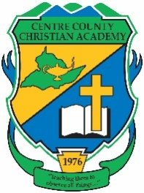



School: Centre County Christian

Team Colors: Green & Gold

Wins _____ Losses ______ Ties _____

Opponent: __________________________

Head Coach: Ken Gore

Assistant Coach: Ryan Smith

Date: ______________________

|  |  |  |  |  |
| --- | --- | --- | --- | --- |
| **Number** | **Name** | **Year** | **Position** | **Homeschool** |
| 38 | Ryan Doherty | 12 |  |  |
| 22 | Jacob Tlumac | 12 |  |  |
| 17 | Mitchell White | 12 |  |  |
| 9 | Max Fedorov | 11 |  | X |
| 19 | Evan Gore | 11 |  |  |
| 13 | Stephan Kondratyev | 11 |  |  |
| 14 | Elliot Pimentel | 11 |  |  |
| 28 | Ben Rossman | 11 |  |  |
| 32 | Grant Smith | 11 | Keeper |  |
| 39 | Isaiah Hoffmann | 10 |  | X |
| 16 | Phillip Maslov | 10 |  | X |
| 42 | James Cool | 9 |  |  |
| 34 | Jacob Kolosov | 9 |  | X |
| 24 | Josiah Pimentel | 9 |  |  |
| 44 | Carsten Shvenke | 9 |  |  |
| 37 | Trent White | 9 |  |  |
| 46 | Daniel Berezhnoy | 8 |  |  |
| 31 | Jac Cool | 8 |  |  |
| 23 | Jason Kerstetter | 8 |  |  |
| 55 | Brock Shipe | 7 |  | X |
| 56 | Julian Shvenke | 7 |  |  |
|  |  |  |  |  |
|  |  |  |  |  |
|  |  |  |  |  |
|  |  |  |  |  |

Official ACAA League Team Roster. to be submitted to the scorer’s table before each game.